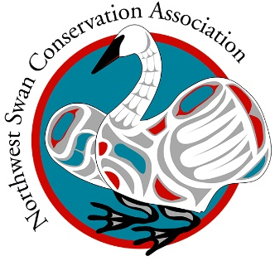
Northwest Swan Conservation Association

Swan Observation Form
(Turn on your INSERT key and type over the appropriate data line)

Date Observed: Month ____ Day ____ Year _____

LOCATION description:
State/Province:___________________ County:________________________
Nearest City/Town:______________________________________
Name of location/intersection/address: __________________________________________
______________________________________________________________________________
(Pond or lake name, wildlife area, name/address of farm, nearest intersection, etc.)

GPS (latitude-longitude) coordinates if known:
(use your smart phone to locate lat/long when you are in the field)
lat:______________________________long:_______________________________
A location you have reported previously? Yes___ No____

WEATHER: Temp. _____F or _____C (put an x next to all that apply)
__Clear __ Partly cloudy __Overcast __Rain __Drizzle __Snow

HABITAT TYPE (if known) __corn __pasture __potatoes __bay __slough __reservoir/lake __flying __winter wheat __ other (list it)________________________
- - - - - - - - - - - - - - - - - - - - - - - - - - - - - - - - - - - - - - - - - - - - - - - - - - - - - - -
SWAN data: Note: adult swans are white, juveniles are grey

Total number Trumpeters ________ Adults __________ Juveniles ___________
Total number Tundras ________ Adults __________ Juveniles ___________
Total number Unknown Swans _____ Adults __________ Juveniles ___________

Mute Swans (very rare)(Orange bill, black knob at base) Adult ____ Juv ____

Activity of majority of swans: Feeding/loafing___ Flying ___ Roost site___

MARKED (neckband or leg band) Trumpeter or Tundra Swans in the group? Y___ N____

Marker codes (indicate color of collar and code, and code letters and numbers)
Species: _______________ Collar: color___________ Code:___________ Leg Band Y__ or N __
Species: _______________ Collar: color___________ Code:___________ Leg Band Y__ or N __
Species: _______________ Collar: color___________ Code:___________ Leg Band Y__ or N __
If you were able to read any or all of the leg band please put it here:
____________________________________________________________

IMPORTANT! Have you reported the marked birds to the US Bird Banding Lab?
Please do so by clicking here: https://www.pwrc.usgs.gov/bbl/bblretrv/index.cfm

Additional Comments: (put observed disturbance or unusual circumstances, odd behaviors, other species seen with the swans, etc.)
___________________________________________________________________________________________________________________________________________________________________________________________________________________________________________________________________________________

- - - - - - - - - - - - - - - - - - - - - - - - - - - - - - - - - - - - - - - - - - - - - - - - - - - - - - - - - - - - - -

OBSERVER INFORMATION:

*Name:_____________________________________
Address _____________________________________________

City, State & ZIP ____________________________________

*Phone ___________________ *Email_____________________________

Prefer contact by: Phone_____ Email______ Mail______

*Your contact information is not shared but we may want to contact you to learn more details of your observation.

_____________________________________________________________________________________

Are you a current MEMBER
of Northwest Swan Conservation Association? Yes__ No__

We welcome your support! Memberships start at $25.00 and details can be found on our website
www.nwswans.org

Would you like to receive our E-NEWS with updates on northwest swan issues and the work we are accomplishing? Yes _____ No _____

Email this form to: swaninfo@nwswans.org

